**SYNOPSIS**

**ON**

**Evergreen Bookstore Website**

**BY**

**Aakanksha Avadhut Mujumdar**

**Under the Guidance of**

**Prof. Prajali Patil**

**SAVITRIBAI PHULE PUNE UNIVERSITY**

**MASTER OF COMPUTER APPLICATION**

**Dr. D.Y. Patil Centre for Management & Research**

**Newale Vasti, Chikhali, Pune-412114**

**Year 2023-2024**

**INTRODUCTION**

Discover a world of literary wonders at Evergreen Book Store, where technology meets literature to create an immersive and seamless reading experience. Oure website is meticulously crafted using Java technologies such as Spring Boot, Hibernate, Servlets, and JSP, supported by the power of JSTL (JavaServer Pages Standard Tag Library). This robust technological foundation ensures a smooth and efficient browsing experience for book enthusiast.

At Evergreen Book Store, we invite you to explore a diverse collection of literary treasures, engage with a user-friendly interface, and enjoy the seamless integration of technology and literature. Weather you are casual reader or a dedicated bookworm, our platform is designed to enhance your reading journey and make discovering new books a delightful experience.

**Embark on literary adventure with Evergreen Book Store - Where every page turns into a new Chapter of discovery!**

**OBJECTIVES**

1. **Enhance User Experience:** The primary objective of the Evergreen Book Store is to provide users with a seamless and enjoyable online shopping experience. This involves creating an intuitive and user-friendly interface that allows customers to easily navigate through the website, discover new books, and make hassle-free purchases. Features such as personalized recommendations, user reviews, and efficient search functionality contribute to an enhanced user experience.
2. **Efficient Book Management and Ordering:** Another key objective is to streamline the management of the book catalogue and ordering process. The website should provide administrators with a robust backend system, powered by technologies like Spring Boot and Hibernate, to efficiently manage book details, inventory, and order processing. This includes real-time updates on stock levels, secure payment processing, and order tracking to ensure timely delivery of purchased books.

**REQUIREMENTS**

* **Hardware Requirements:**
* Processor 🡺 Intel Core i3
* Hard Disk 🡺 512GB
* RAM 🡺 4GB
* **Software Requirements:**
* Operating System 🡺 Windows 7 or later, macOS, Linux
* Tools/IDE 🡺 Eclipse

**FRONTEND**

1. **HTML:** Defines the basic structure of Evergreen Book Store's webpages, specifying elements like headers, footers, and content sections to organize information.
2. **CSS:** Styles the visual presentation of the website, determining the layout, colors, and fonts for a cohesive and attractive design.
3. **JavaScript:** Adds interactivity to Evergreen Book Store, allowing dynamic content updates, form validation, and other client-side functionalities without page reloads.
4. **JSP With JSTL:** Integrates Java code into webpages, enabling server-side rendering for dynamic content retrieval and display in Evergreen Book Store.
5. **Bootstrap:** Utilizes a CSS framework to streamline design, providing ready-made components for a consistent, mobile-friendly layout across devices in Evergreen Book Store.

**BACKEND**

1. **Java(Programming language):** Forms the core backend logic of Evergreen Book Store, handling data processing, business logic, and overall application functionality.
2. **Spring Boot (Framework):** Streamlines backend development, offering a lightweight and efficient framework for building scalable and modular Java applications, such as Evergreen Book Store.
3. **Hibernate(ORM Framework):** Manages the interaction between Java objects and the MySQL database, facilitating data persistence and retrieval for Evergreen Book Store.
4. **Servlets:** Handle HTTP requests and responses, managing the flow of communication between clients and the server in Evergreen Book Store.

**MODELS NAME:**

1. **Book 🡺** book_id, title, author, description, isbn, image, price, publish_date, last_update_time, category**_**id
2. **Book_Order 🡺** order_id, customer_id, order_date, shipping_address, recipient_name, recipient_phone, payment_method, total, status
3. **Category 🡺** category_id, name
4. **Customer 🡺** customer_id, email, fullname, address, city, country, phone, zipcode, password, register_date
5. **Order_Detail 🡺** order_id, book_id, quantity, subtotal
6. **Review 🡺** review_id, book_id, customer_id, rating, headline, comment, review_time
7. **Users 🡺** user_id, email, password, full_name

**CLASS DIAGRAM**

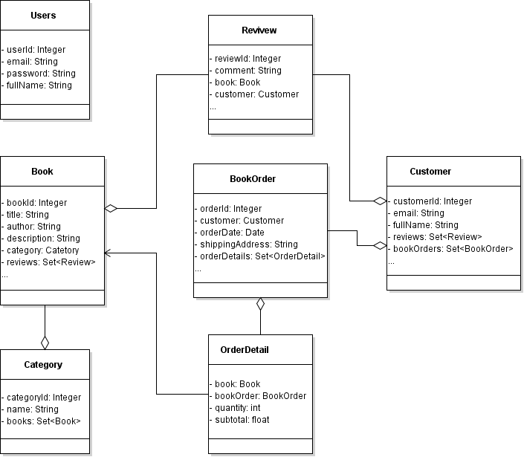

**USE CASE DIAGRAM**

